Using Qualtrics Data to Explore the Association Between Graduate Student Decision-Making and Their Pizza Order

Miao Cai

Madhav Narayan

Florida Uzoaru

Kristina Vidovic

Abstract

Extant literature suggests graduate students are more likely to experience depression and anxiety as compared to the general population; unstable mental health is associated with impartial decision-making behavior. One coping technique to stabilize mental health is eating comfort foods. Prior research suggests that American adults’ primary comfort food of choice is pizza. Given the lack of research on the decision-making processes of graduate students and their comfort food choices, we explore the association between student decision-making and their pizza order. A self-report electronic survey--using Qualtrics--was sent out to students (n = 19) in a public health class regarding their most-preferred crust, sauce, cheese, meat, and various toppings. A series of descriptive statistical analyses indicated that the majority of participants preferred marinara sauce (73.7%), mozzarella cheese (50%), pepperoni (35.7%), and tomato (52.6%) on their pizza. Further, participants indicated they would either prefer oregano (31.6%) or no seasoning on their pizza (31.6%). Study findings do not deviate from what is generally preferred in the United States. Administering electronic surveys through Qualtrics software should be considered as an effective e-epidemiological method of data collection.

Key Words: students, preferences, pizza

**1. Introduction**

Pursuing graduate education is an expensive, time-consuming, and stressful commitment for many students. Evans et al. (2018) surveyed graduate students who represent a diverse range of disciplinary orientations (e.g., physical science, engineering, humanities, and social sciences) from 26 countries. The authors reported that graduate students are more than six times as likely to experience moderate to severe depression and anxiety as compared to the general population (39-41% of students as compared to 6% of the general population). Those who struggle with stabilizing their mental health participate in a multitude of coping techniques; examples range from engaging in therapy sessions, to eating their favorite foods. A survey conducted by The Harris Poll (2016) regarding the eating habits of American adults during times of mental stress found that 53% admitted to eating more when going through a difficult time. Further, 67% said they had a favorite comfort food they go to for relief, with pizza identified as the primary food of choice.

Although pizza consumption is not the healthiest coping option, it is accessible due to the minimal money and time it takes to order a pizza. Ordering pizza, especially in group situations, may be more difficult for populations that experience mental stress. Depressed and anxious moods inﬂuence decision-making behavior, in that it contributes to higher impartiality in collecting information about decision alternatives (Lewicka, 1997; Kuhl, 1984). In other words, when asked what they want on a pizza, a graduate student may state that they are impartial and happy with everyone else’s choice rather than telling the group their preferences. Given the relative lack of research on the decision-making processes of graduate students and their comfort food choices, we explore the association between student decision-making and their pizza order. The research question posed is, without any consideration of cost, what type of pizza is most preferred by graduate students?

**2. Methods**

A cross-sectional study design was employed. The sample was composed of students enrolled in a graduate-level public health class at a university in the Midwestern United States. This class was convenience sampled. The inclusion criteria was participants being registered in the class. At the time of data collection, 23 participants (including the instructor) were eligible; 19 of them (82.7%) agreed to participate, forming the final sample.

A self-report electronic survey--created using Qualtrics software--was sent out to the class via email. If participants agreed to fill out the survey, they were asked a series of questions about their most-preferred crust, sauce, cheese, meat, and various toppings. An image of each choice was attached in order to aid participants in delineating the various types of crusts, sauces, and toppings. The data were then exported as a comma-separated value file from Qualtrics. Data analyses were conducted in R 3.6.0 .

**3. Results**

Please refer to Appendix A for figures depicting preferred pizza crust, sauce, cheese, meat, vegetable topping, and seasoning. The most popular pizza crust was cheese-stuffed (31.6%), followed by neapolitan (26.3%), deep dish (21.1%), and sicilian style (15.8%). One respondent did not specify crust preference. 14 respondents (73.7%) chose marinara sauce. Among the 19 participants, 16 (84.2%) claimed that they wanted cheese on their pizza. Of the 15 people who specified the choice of cheese, 53.3% chose mozzarella, followed by cheddar (20%), asiago (20%), provolone (12.5%). One respondent, despite indicating a preference for cheese in the pizza, did not specify the type of cheese. Among the 19 participants, 14 (73.7%) wanted meat on their pizza. The most popular meat was pepperoni (35.7%), sausage (28.6%), and chicken (21.4%). One respondent claimed he or she wanted meat but did not specify the type of meat. The most preferred vegetable was tomato (52.6%), followed by onion (21.1%), green pepper (10.5%), and olives (5.3%). Two respondents did not want vegetables on their pizza. The favorite seasoning was oregano (31.6%), followed by olive oil drizzle (15.8%), sea salt (15.8%), and balsamic vinegar drizzle (5.3%). Six out of the 19 respondents (31.6%) did not want seasoning on their pizza.

**4. Discussion**

Given that we had a high response rate (82.7%), our results are fairly representative of the class as a whole. We found a majority of participants preferred marinara sauce (73.7%) and mozzarella cheese (50%). They are both considered to very common pizza sauce and cheese options respectively. Additionally, the most popular meat was pepperoni (35.7%), which is in line with previous research. For example, a 2019 online survey by YouGov reported that 52% of Americans said pepperoni is one of their favorite pizza toppings.

Qualtrics as a tool demonstrates the effectiveness of e-epidemiological methods of data collection. The survey was easily administered and could easily be implemented on a larger scale. The ability to gate questions is also useful in that it can help ensure that only applicable questions have answers collected for them. Additionally, since location data for responses are collected, there is potential for future research to see whether pizza preferences are impacted by geographical locations and their respective “styles” of pizza (ie. Chicago deep-dish, Detroit square pizza, etc.). Further, electronic surveys can aid professors and student association leaders in ordering pizza, as well as other comfort foods, for class events that potentially unstable and indecisive graduate students attend.

**References**

Ballad, J. (2019). Does pineapple belong on pizza? [Web page]. *YouGov.* Retrieved from https://today.yougov.com/topics/food/articles-reports/2019/02/04/pineapple-pizza-toppings-pepperoni-popular?nh=find-solutions,omnibus

Birth, A. (2016). Comfort foods, sickbed snacks and celebratory nosh: What are Americans’ favorites [Web page]. *The Harris Poll.* Retrieved from https://theharrispoll.com/theres-really-no-debate-that-food-can-be-a-comfort-whether-stressed-or-depressed-almost-everyone-has-a-favorite-go-to-dish-that-seems-to-help-make-everything-all-better-just-over-half-53/

Evan, T. M., Bira, L., Gastelum, J. B., Weiss, L. T., & Vanderford, N. L. (2018). Evidence for a mental health crisis in graduate education. *Nature Biotechnology, (3).* DOI: 10.1038/nbt.4089

Kuhl, J. (1984). Volitional aspects of achievement motivation and learned helplessness: Towards a comprehensive theory of action control. In B. A. Maher (Ed.), *Progress in experimental personality research*, 12, 9–170. New York: Academic Press.

Lewicka, M. (1997). Rational or uncommitted? Depression and indecisiveness in interpersonal decision making. *Scandinavian Journal of Psychology, 38,* 227–236.

Team, R. C. (2013). R: A language and environment for statistical computing.

Appendix A

Participant responses to survey questions

**Figure 1:** Participant responses to preferred pizza crust.

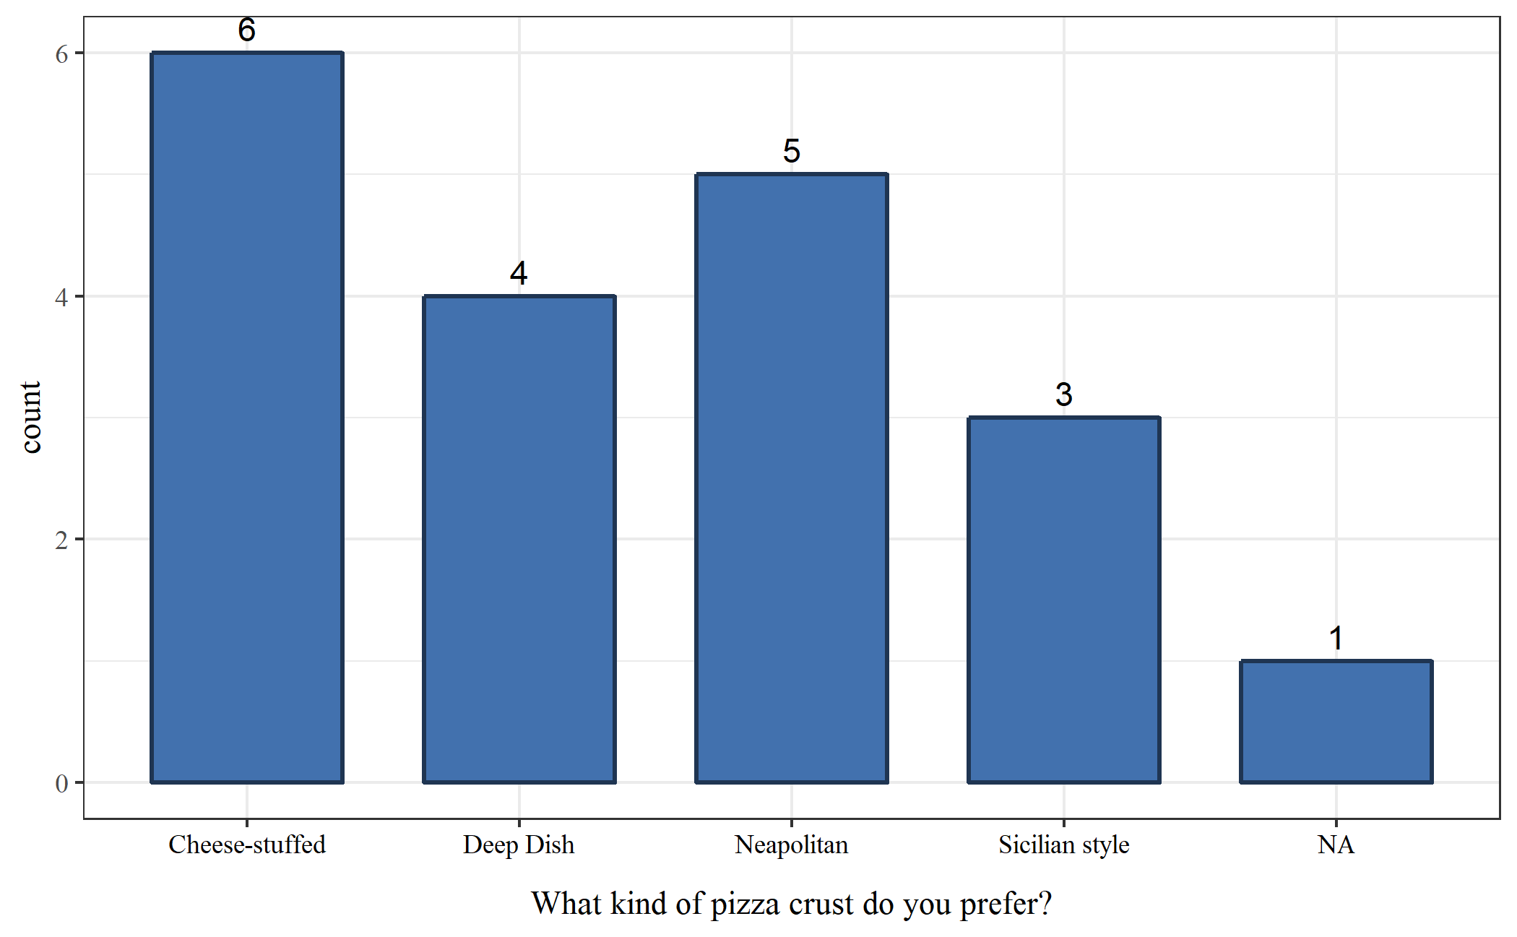

**Figure 2:** Participant responses to preferred pizza sauce.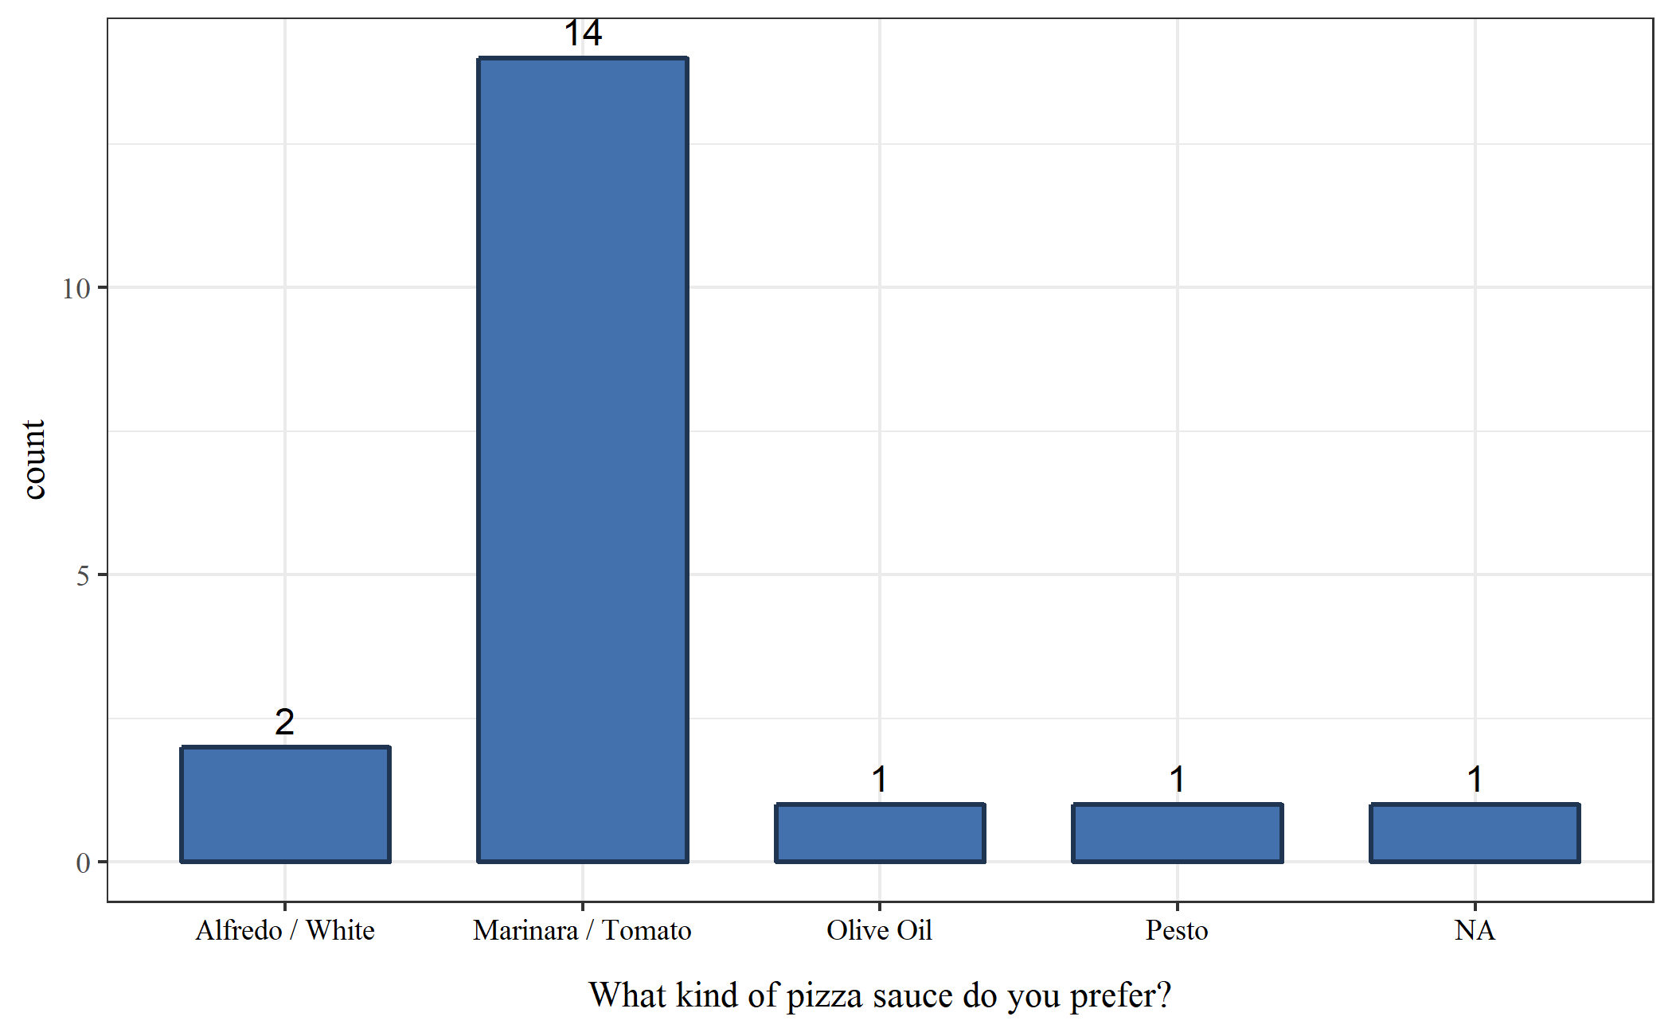

**Figure 3:** Participant responses to preferred pizza cheese.

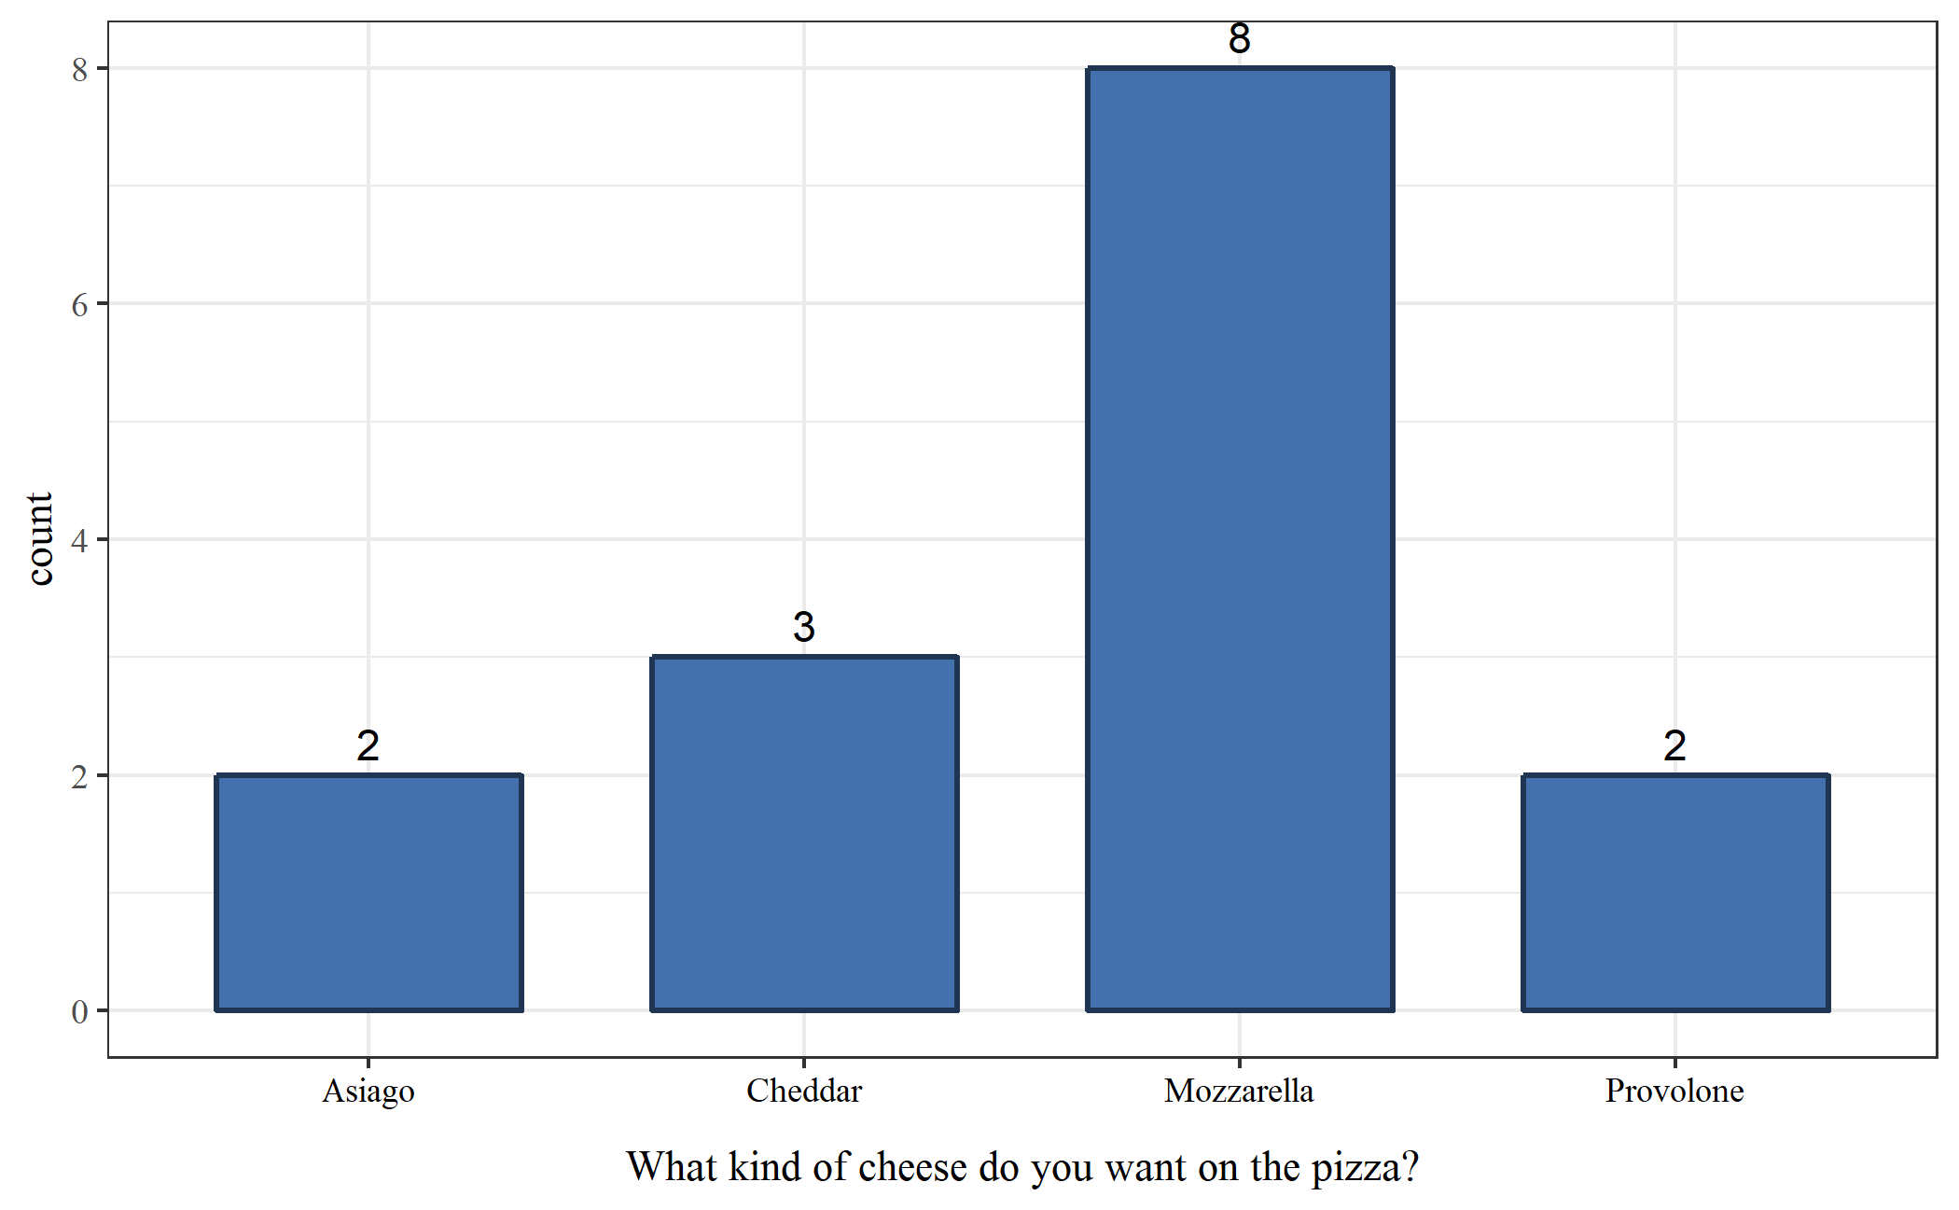

**Figure 4:** Participant responses to preferred pizza meat.

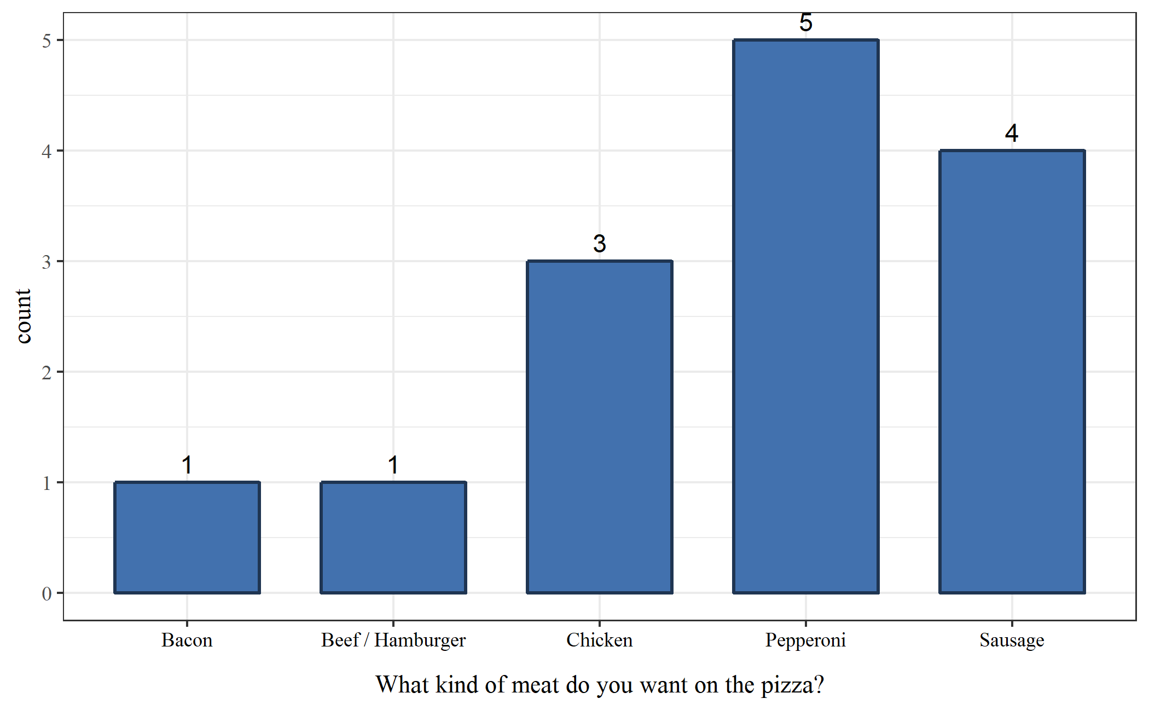

**Figure 5:** Participant responses to preferred vegetable topping.

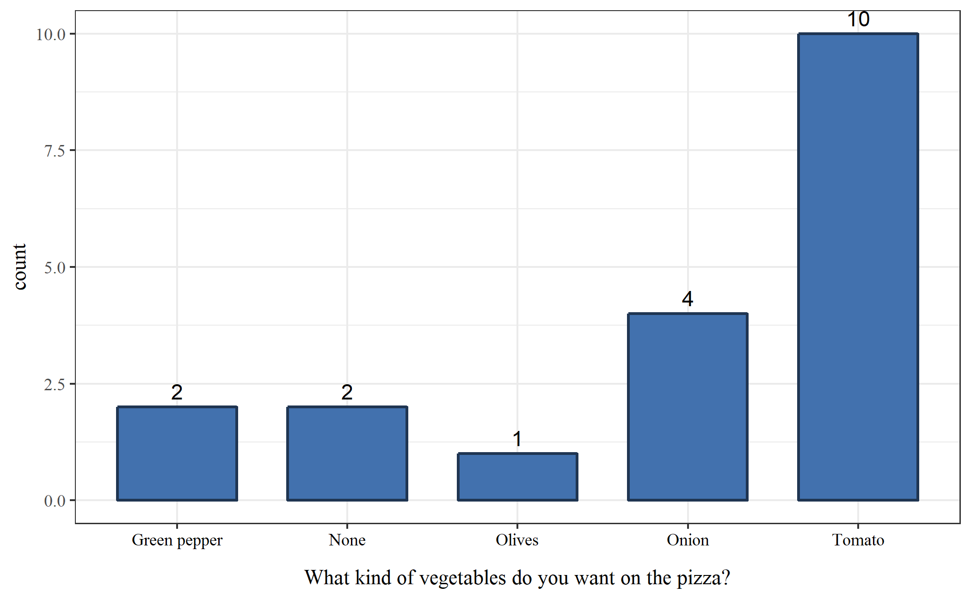

**Figure 6:** Participant responses to preferred seasoning.

